**Microsoft Visual Studio C++ 2010 Express**

1. Launching the application

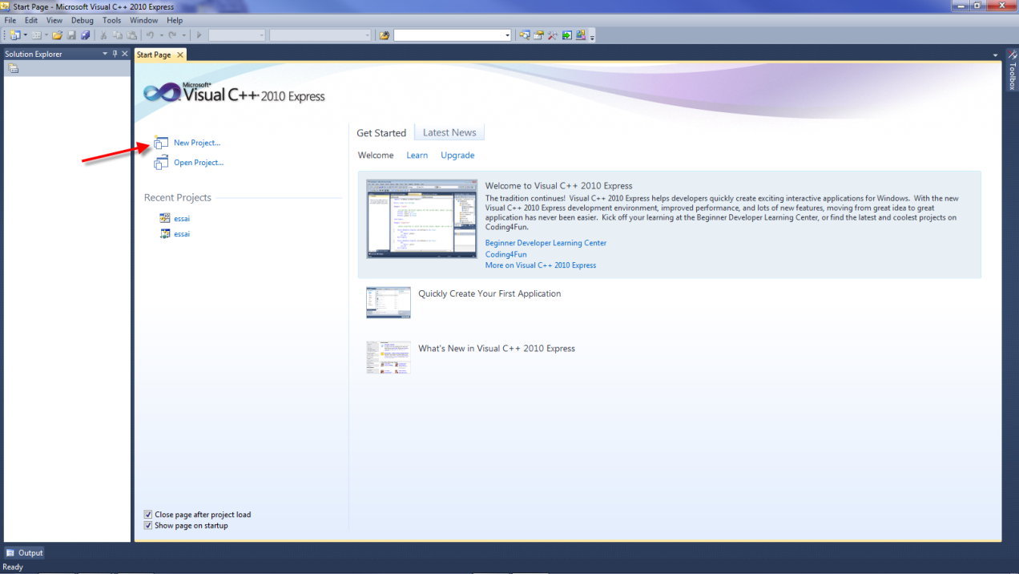

Select **New Project...**

1. Creating a new project

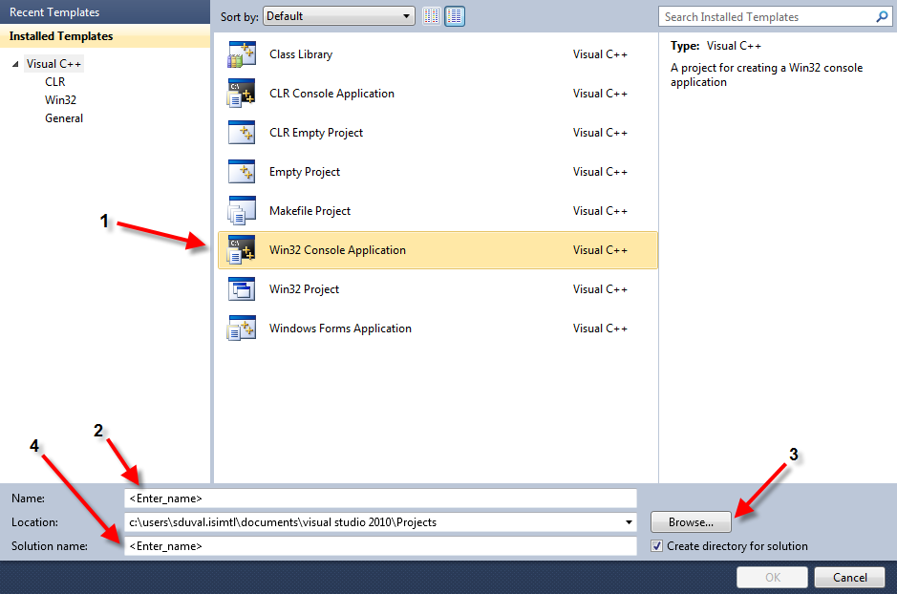

1 – Select **Win32 Console Application**

2 – **Name:** Enter the name of the project

3 – **Location:** Specify the directory in which to place the project

4 – **Solution name:** Enter the name of the solution, or keep the default name provided

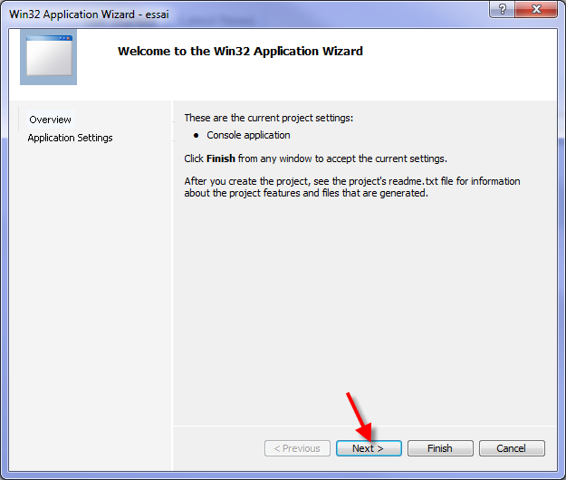 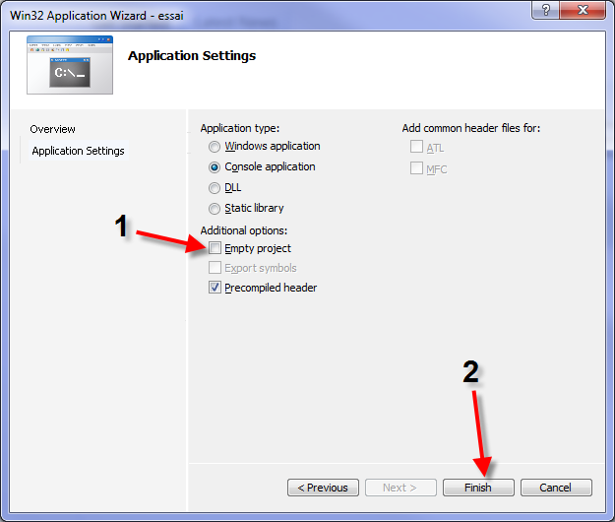

Click **Next >** 1 – Check **Empty project**

2 – Click **Finish**

1. Adding a source file

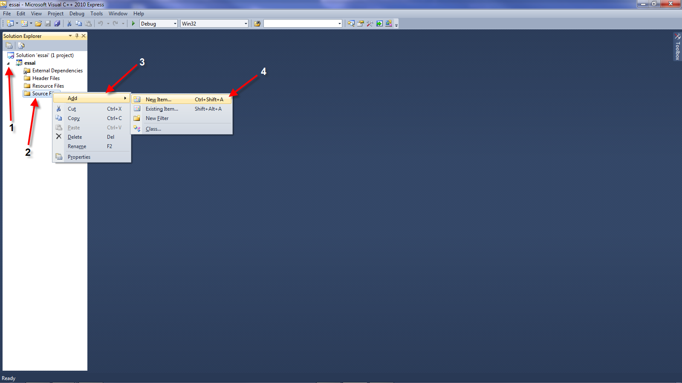

1 – In the **Solution Explorer**, expand your project

2 – Right-click on **Source Files**

3 – Select **Add**

4 – Select **New Item...**

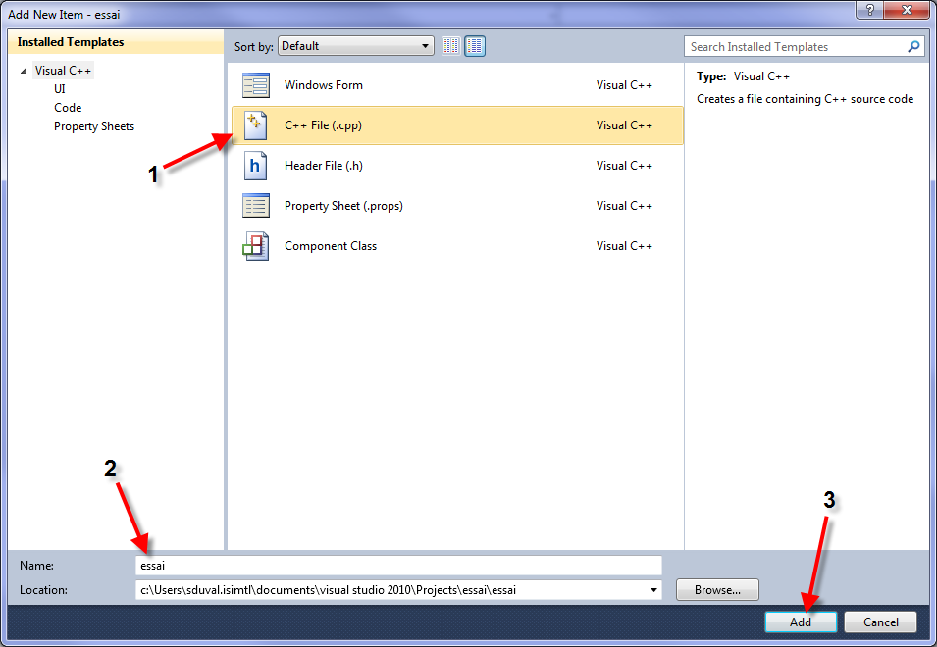

1 – Select **C++ File (.cpp)**

2 – **Name:** Enter the name of the file

3 – **Add:** Add the new file

1. First C++ program

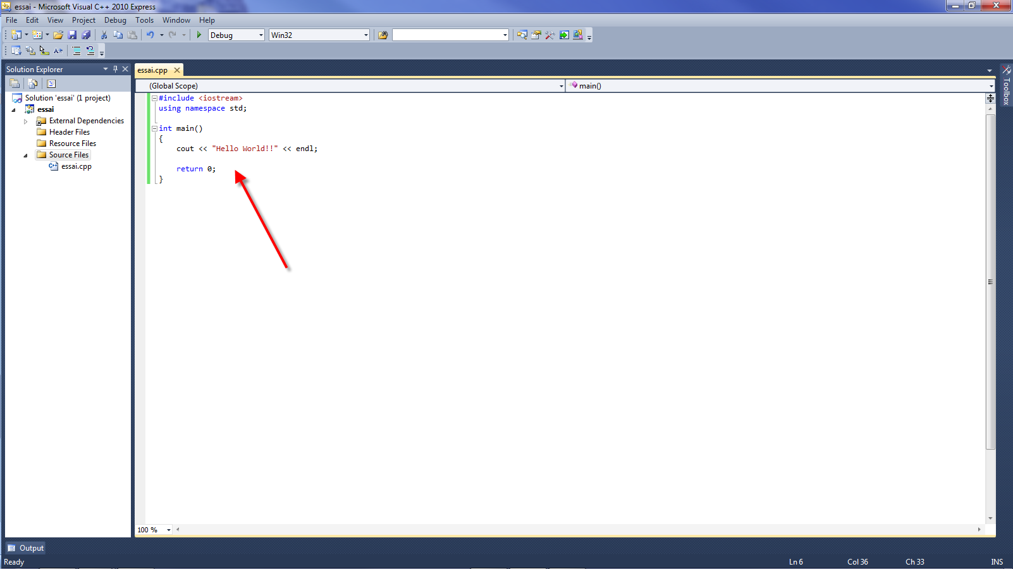

Enter your source code

Execute the program by pressing **CTRL-F5**

